Testing and Commissioning Procedure

Disclaimer: This sample document is an example for purposes of illustration only and is intended to serve only as a general resource, not as a form or recommendation.

Check-list before the Site Test
- Perform visual inspection for the whole RE/BESS system.
- Check all wiring connections for the whole RE/BESS system.
- Anti-islanding Test
  - Connect the voltage terminals & current transformer (CT) of oscilloscope / data logger to the RE/BESS system side of 4P lockable switch (Isolation Point).
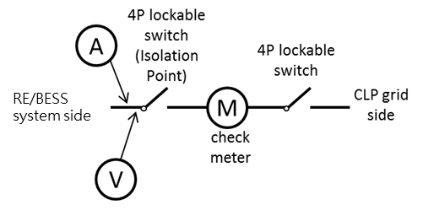
  - Close XXA 4P lockable switch located at XXXXX from the grid supply side.
  - Close XXA 4P lockable switch (Isolation Point) located at XXXXX from the RE/BESS system side.
  - Close all the below switching devices in MCB board,
    - XXXXX
    - XXXXX
  - Simulate the system disturbance by opening the lockable isolation switch (Isolation Point), record the voltage and current waveforms by oscilloscope/data logger to demonstrate the anti-islanding time <200ms.
- Check for the “Grid Turn-on Delay” for the RE/BESS system is 300 sec.
- The harmonic content of voltage and current waveforms will be recorded by oscilloscope/data logger.
- Review and download the record waveform/data from oscilloscope/data logger.
- Complete the T&C Report & Electricity (Wiring) Regulations, Work Completion Certificate – WR1 form, and receipt issued by EMSD evidencing payment for Registration of Generating Facility, if applicable, then sent to CLP for arranging CLP witness of site test.
Testing and Commissioning Procedures for Grid Connection of RE/BESS System
- Check installation, earth bonding and wiring for the grid-connection section.
- Harmonic current distortion test as per “Check-list before the Site Test”.
- Demonstrate anti-islanding protection circuit to meet 0.2s protection time as per “Check-list before the Site Test”.
- Measure the earth fault loop impedance of the RE/BESS system.
- Measure the line-neutral loop impedance of the RE/BESS system.
- Measure the RCD/RCBO trip time if applicable.
- Inspect DC & AC dual-source warning labels along the path from RE/BESS system to CLP’s power infeed.

Part 1 – Grid Connected Renewable Energy/Battery Energy Storage System Summary
A) RE/BESS System Information
CLP’s Application No.
RE/BESS Type
Power Rating (kW)
Current Rating (A) -
No. of Phase
RE/BESS Installation Address
B) Lift Availability (only apply to new construction building)
Lift availability? |  |  |  | ☐ Yes | ☐ No Remarks:
C) Contractor Information
Contact Person
Phone Number
D) Documents Submitted (Please tick where applicable) |  |  |  |  |  |  | No of Sheet | Remarks
☐ | Part 1 – Grid Connected Renewable Energy/Battery Energy Storage System Summary
☐ | Part 2 – T&C Results & Photos
☐ | Part 3 – Photos for Renewable Energy/Battery Energy Storage System Installation
 | ☐ | 3.1 - Overview of RE/BESS equipment (e.g. PV Panels, Wind Turbine, & BESS etc) and RE/BESS equipment inside Plant Rooms (e.g. Inverter, switchgear & etc)
 | ☐ | 3.2 - Nameplate & Technical Data Plate & Installation of RE/BESS equipment (e.g. Inverter, isolation transformer & etc)
 | ☐ | 3.3 - Earthing Connection of RE/BESS equipment
 | ☐ | 3.4 - DC warning labels at all DC Switchgear & panel and rating of all DC switchgears
 | ☐ | 3.5 - AC dual source power supply warning labels at all AC switchgear & panel and rating of all AC switchgears (along the path from RE system to CLP’s power infeed)
 | ☐ | 3.6 - PV Schematics & Main Electrical Schematic Diagram (with cloud mark of RE/BESS System) in Plant Rooms
 | ☐ | 3.7 - FiT/RE Meter Location, Meter Board’s dimension & Cable Terminations
 | ☐ | 3.8 - CLP’s Revenue Meter & Substation
☐ | Part 4 – RE/BESS System Setting
 | ☐ | 4.1 - Voltage Protection
 | ☐ | 4.2 - Voltage Control
 | ☐ | 4.3 – Over Frequency Response
 | ☐ | 4.4 – RE/BESS System re-closing time should be ≥ 5 minutes
☐ | Part 5 – Other Related Information (e.g. other related RE system or special information)
☐ | Operation Procedure
 | ☐ | Cover Page (Basic Information, Safety Procedure, Attachment List, REC & REW Information & Signature)
 | ☐ | Renewable Energy/Battery Energy Storage System Schematic
 | ☐ | Main Electrical Schematic
 | ☐ | Renewable Energy/Battery Energy Storage System Location Plan in the Premises
 | ☐ | CLP’s RE/FiT Meter Location Plan with access route
☐ | Electricity (Wiring) Regulations, Work Completion Certificate – WR1 form
 | ☐ |  | Part 1, 2 & 3 from Form WR1
 | ☐ |  | Renewable Energy/Battery Energy Storage System Schematic

Part 2 – T&C Results & Photos
☐ | Single Phase RE/BESS System (Please only provide test results for the connected phase L1/L2/L3)
☐ | Three Phase RE/BESS System (Please only provide test results for all three phases L1, L2 & L3)  (Remark: either one photo for all three phases test result or three separate photos for single phase results)
Tests |  | Photos & Results
Anti-islanding time |  | Phase L1 | Phase L2 | Phase L3
 |  | 
 |  | Results: ms | Results: ms | Results: ms
Total Harmonic Current Distortion (should not exceed 5%)
 |  | Results: % | Results: % | Results: %

Part 2 – T&C Results & Photos
Tests |  |  | Photos & Results
 |  |  | Phase L1 |  | Phase L2 |  | Phase L3
Earth fault loop impedance
(should comply with EMSD’s CoP)
 |  |  | Results: Ω |  | Results: Ω |  | Results: Ω
Line to neutral loop impedance
 |  |  | Results: Ω |  | Results: Ω |  | Results: Ω
RCD/RCBO trip time
(if applicable)
 |  |  | Results: ms |  | Results: ms |  | Results: ms
Part 3 – Photos for Renewable Energy/Battery Energy Storage System Installation
3.1 - Overview of RE/BESS equipment (e.g. PV Panels, Wind Turbine, BESS, & etc) and RE/BESS equipment inside Plant Rooms (e.g. Inverter, switchgear & etc)
Description
Photos
Description
Photos
Part 3 – Photos for Renewable Energy/Battery Energy Storage System Installation (Cont’d)
3.2 – Nameplate, Technical Data Plate & Installation of RE/BESS equipment (e.g. Inverter, isolation transformer & etc)
Description
Photos
Description
Photos
Part 3 – Photos for Renewable Energy/Battery Energy Storage System Installation (Cont’d)
3.2 - Nameplate & Technical Data Plate of RE/BESS equipment (e.g. Inverter, isolation transformer & etc)
Description
Photos
Description
Photos
Part 3 – Photos for Renewable Energy/Battery Energy Storage System Installation (Cont’d)
3.3 - Earthing Connection of RE/BESS equipment
☐ | PV System (Please only provide information in 3.3.1)
☐ | Wind Turbine System/Battery Energy Storage System (Please only provide information in 3.3.2)
☐ | 3.3.3 Others
3.3.1 Earthing Connection of PV system
☐ | PV Panels Metallic Frame to PV Panels Metallic Frame (Typical)
☐ | PV Panels Metallic Frame to PV Panels Metallic Supporting Frame (Typical)
☐ | PV Panels Metallic Supporting Frame to Earthing Terminal (Typical)
Description |  | Choose an item. |  |  |  | Choose an item.
Photos
Description |  | Choose an item. |  |  |  | Others:
Photos

Part 3 – Photos for Renewable Energy/Battery Energy Storage System Installation (Cont’d)
3.3 - Earthing Connection of RE/BESS equipment (Cont’d)
3.3.2 Wind Turbine Metallic Parts / BESS to Earthing Terminal
Description
Photos
3.3.3 Others
Description
Photos
Part 3 – Photos for Renewable Energy/Battery Energy Storage System Installation (Cont’d)
3.4 - DC warning labels at all DC Switchgear & panel and rating of all DC switchgears (Cont’d)
Please attach the PV/BESS Schematic and add cloud mark indication for DC warning labels at DC switchgear/DC switchgears’ metal box and attach their photos with description on the next page.
Part 3 – Photos for Renewable Energy/Battery Energy Storage System Installation (Cont’d)
3.4 - DC warning labels at all DC Switchgear & panel and rating of all DC switchgears (Cont’d)
Description | Choose an item. |  | Choose an item.
Photos
Description | Choose an item. |  | Choose an item.
Photos
Part 3 – Photos for Renewable Energy/Battery Energy Storage System Installation (Cont’d)
3.4 - DC warning labels at all DC Switchgear & panel and rating of all DC switchgears (Cont’d)
Description | Choose an item. |  | Choose an item.
Photos
Description | Choose an item. |  | Choose an item.
Photos
Part 3 – Photos for Renewable Energy/Battery Energy Storage System Installation (Cont’d)
3.4 - DC warning labels at all DC Switchgear & panel and rating of all DC switchgears (Cont’d)
Description | Choose an item. |  | Choose an item.
Photos
Description | Choose an item. |  | Choose an item.
Photos
Part 3 – Photos for Renewable Energy/Battery Energy Storage System Installation (Cont’d)
3.5 - AC dual source power supply warning labels at all AC switchgear & panel and rating of all AC switchgears (along the path from RE/BESS system to CLP’s power infeed)
Please attach the PV/BESS Schematic and add cloud mark indication for AC dual source power supply warning labels at all AC switchgear & panel and attach their photos with description on the next page.
Part 3 – Photos for Renewable Energy/Battery Energy Storage System Installation (Cont’d)
3.5 - AC dual source power supply warning labels at all AC switchgear & panel and rating of all AC switchgears (along the path from RE/BESS system to CLP’s power infeed) (Cont’d)
Please attach the Main Electrical Schematic and add cloud mark indication for AC dual source power supply warning labels at all AC switchgear & panel and attach their photos with description on the next page.
Part 3 – Photos for Renewable Energy/Battery Energy Storage System Installation (Cont’d)
3.5 - AC dual source power supply warning labels at all AC switchgear & panel and rating of all AC switchgears (along the path from RE/BESS system to CLP’s power infeed) (Cont’d)
Description | Choose an item. |  | Choose an item.
Photos
Description | Choose an item. |  | Choose an item.
Photos
Part 3 – Photos for Renewable Energy/Battery Energy Storage System Installation (Cont’d)
3.5 - AC dual source power supply warning labels at all AC switchgear & panel and rating of all AC switchgears (along the path from RE/BESS system to CLP’s power infeed) (Cont’d)
Description | Choose an item. |  | Choose an item.
Photos
Description | Choose an item. |  | Choose an item.
Photos
Part 3 – Photos for Renewable Energy/Battery Energy Storage System Installation (Cont’d)
3.5 - AC dual source power supply warning labels at all AC switchgear & panel and rating of all AC switchgears (along the path from RE/BESS system to CLP’s power infeed) (Cont’d)
Description | Choose an item. |  | Choose an item.
Photos
Description | Choose an item. |  | Choose an item.
Photos
Part 3 – Photos for Renewable Energy System Installation (Cont’d)
3.5 - AC dual source power supply warning labels at all AC switchgear & panel and rating of all AC switchgears (along the path from RE/BESS system to CLP’s power infeed) (Cont’d)
Description | Choose an item. |  | Choose an item.
Photos
Description | Choose an item. |  | Choose an item.
Photos
Part 3 – Photos for Renewable Energy/Battery Energy Storage System Installation (Cont’d)
3.6 – PV/BESS Schematics & Main Electrical Schematic Diagram (with cloud mark of RE/BESS System) in Plant Rooms
Description
Photos
Description
Photos
Part 3 – Photos for Renewable Energy/Battery Energy Storage System Installation (Cont’d)
3.7 – FiT/RE Meter Location, Meter Board’s dimension & Cable Terminations
Description | Choose an item. |  | Choose an item.
Photos
Description | Choose an item. |  | Choose an item.
Photos

Part 3 – Photos for Renewable Energy/Battery Energy Storage System Installation (Cont’d)
3.8 – CLP’s Revenue Meter & Substation
Description | Choose an item. | Choose an item.
Photos
Description | Choose an item. | Choose an item.
Photos

Part 4 – RE/BESS System Setting
4.1 – Voltage Protection – (Please provide RE/BESS information/photos as below example)
Description
Photos | 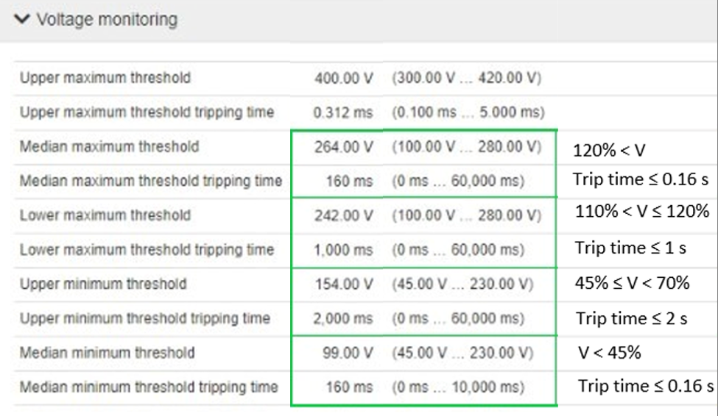
  Voltage at the Connection Point | Trip Time Requirement (second)
  V > 1.20 p.u. | 0.16
  1.10 p.u. < V ≤ 1.20 p.u. | 1
  0.20 p.u. ≤ V < 0.70 p.u. | 2
  V < 0.20 p.u. | 0.16
Description
Photos

Part 4 – RE/BESS System Setting
4.2 – Voltage Control – (Please provide RE/BESS information/photos as below example)
Description
Photos | 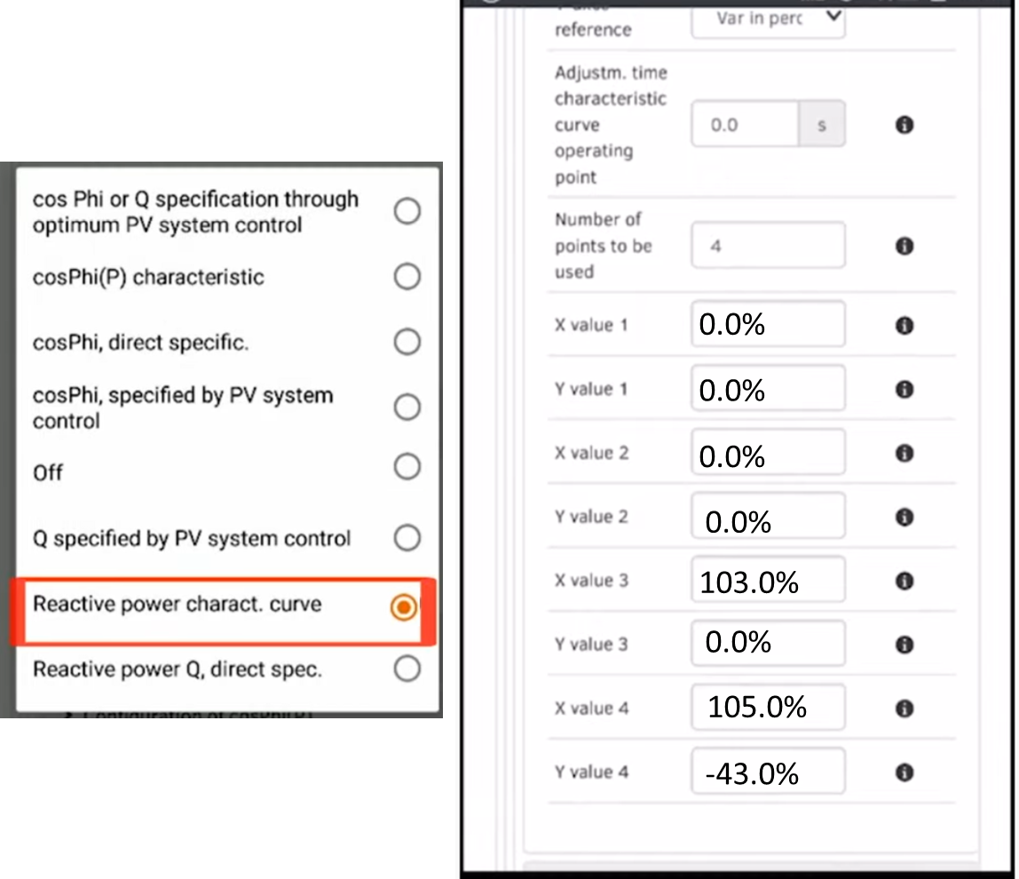 | 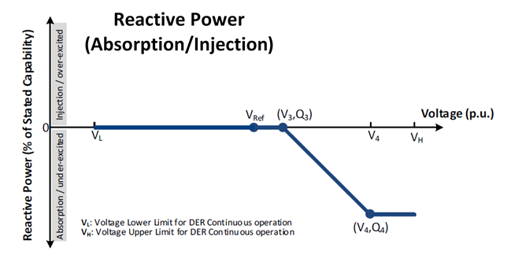  Recommended setting:  V₃ = 103%, Q₃ = 0% rating of the RE/BESS System  V₄ = 105%, Q₄ = Q_{max} ≥ 43% rating of the RE/BESS System
Description
Photos | 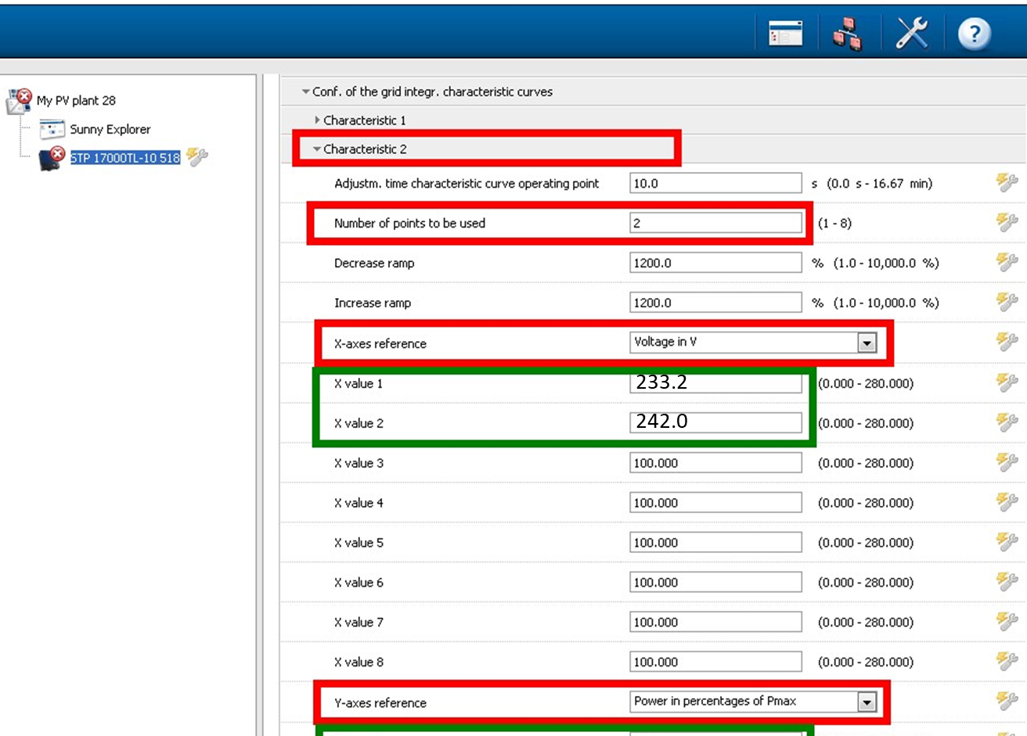 | 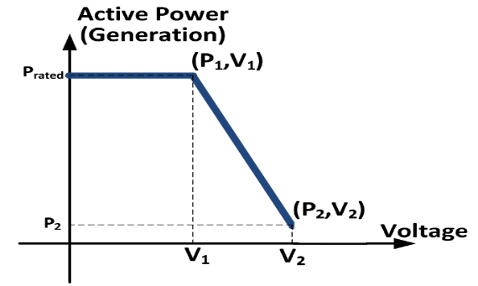  (p.u.)  Recommended setting:  V₁ = 106%, P₁ = 100% rating of the RE/BESS System  V₂ = 110%, P₂ = P_{min} ≤ 20% rating of the RE/BESS System

Part 4 – RE/BESS System Setting
4.3 – Over Frequency Response (Please provide RE/BESS information/photos as below example)
Description |  | High and low frequency ride through setting (Please keep in this report)
Photos | 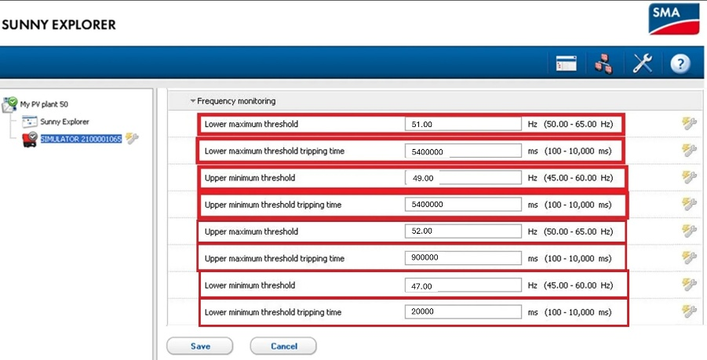
  Frequency range | Duration
  47 – 47.5 Hz | Operation for a period of at least 20 seconds
  47.5 – 49 Hz | Operation for a period of at least 90 minutes
  49 – 51 Hz | Continuous operation required
  51 – 51.5 Hz | Operation for a period of at least 90 minutes
  51.5 – 52 Hz | Operation for a period of at least 15 minutes
Description |  | High Frequency Active Power Response setting (Please keep in this report)
Photos |  | 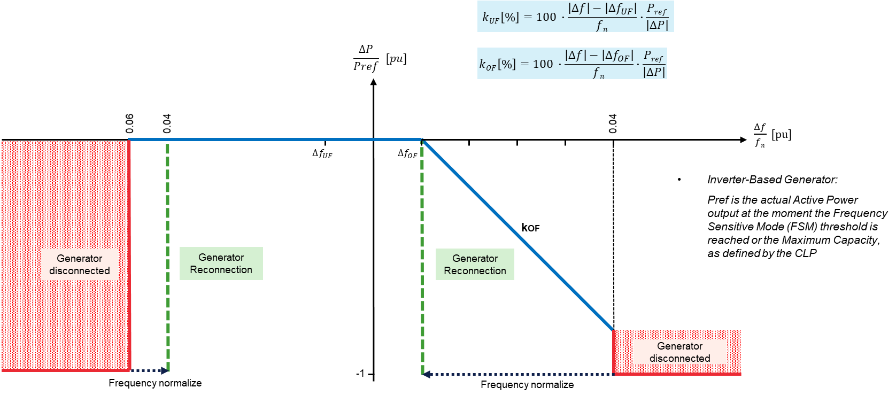  Recommended setting:  Droop setting: 4%  Frequency setting: 50.1Hz

Part 4 – RE/BESS System Setting
4.4 – RE/BESS System re-closing time should be ≥ 5 minutes
Description
Photos
Description
Photos

Part 5 – Other Related Information (e.g. other related RE/BESS system or special information)
Description
Photos
Description
Photos

Part 5 – Other Related Information (e.g. other related RE/BESS system or special information)
Description
Photos
Description
Photos

